
Accessibility in Brightspace
Creating Accessible courses in Brightspace
Making sure students, faculty, and more have access to course materials is an easy process when the building blocks are created with accessibility in mind.

Built-in Tools for Accessibility
Brightspace has a few tools to make accessibility easy.

Using the Text Editor (HTML)
When creating and adding text to content using the native rich text editor it is best practice to use the built-in formatting tools.
Above is an image of the formatting toolbar that appears in the text box when a post is created or edited.
The toolbar enables users to create encoded text elements like:
- Unordered lists (bulleted)
- Ordered lists (Numbered)
- Headings
- Paragraphs
- Hyperlinks
Using the tools provided by the text editor allows screen readers and other accessibility tools to identify the structure of the text.

Brightspace Ally
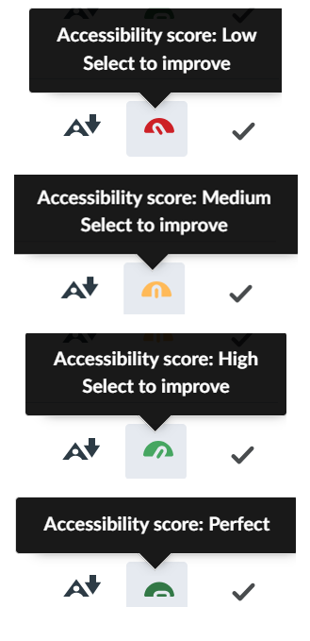
The Ally tool provides an accessibility score for files uploaded or created in the “Content” area of courses. It assigns an accessibility score of Low, Medium, High, or Perfect.For scores less than Perfect, users may select the dial icon and Ally provides a report of accessibility concerns. Some of the accessibility concerns can be addressed in Brightspace like a missing document title. Most of the concerns must be addressed in the document editor (i.e. Adobe for PDFs, Word for .Docx).
Ally cannot discern context or intent, so do not worry about a less than perfect score. For example, certain documents in this course contain elements that purposefully violate accessibility guidelines for comparison.

Best Practices
- Use consistent module structure
- Avoid dumping all materials in one long list
- Name items clearly (“Week 3 Discussion” vs. “Discussion 3”)
- Keep navigation predictable
- Avoid unnecessary nesting
- Due dates help learners stay organized

Multimedia
There are three categories of media: audio-only, video-only, and audio + video.
For audio-only content there needs to be a transcript or a text alternative. This is for people who are hard of hearing or have audio-processing disorders but it’s also useful for those whose first language is not the one being spoken.
For Video-only content it is best practice to have audio-description available or a text alternative. Audio-description is a time consuming and detailed process that has not yet been automated on most video hosting platforms.
For audio and video content use captioning and audio description when available or have a text alternative.
Tip: close your eyes and listen to the audio, are you able to discern the important points from sound and dialogue alone? If not, provide a text alternative like a summary of the important points.

